MINISTRY OF EDUCATION AND SCIENCE OF UKRAINE

NATIONAL TECHNICAL UNIVERSITY

“KHARKOV POLYTECHNICAL INSTITUTE”

LABORATORY WORK № 2

“C++ Operators and Statements”

Created by student of 1.КН.201.8г

Ohol K.V

Teacher

Lutenko I.V

KHARKIV 2018

Topic: C++ Operators and Statements  
Goal: Learning basic principles of C++

Tasks:

1.Develop a program that implements an algorithm for solving quadratic equation. The algorithm should consider all possible data.

2.Develop a program that implements an algorithm for calculating the following expression. Provide a check of possible errors.

y = 1/(x + 2) + 2/(x + 4) + ... + (k - 1)/(x + 2(k - 1)) + (k + 1)/(x + 2(k + 1)) + ... + n/(x + 2n)

3.Write a program that reads x and n and calculates y:  
 y = (x + 1)(x - 2)(x + 3)(x - 4) ... (x - 2n)

4.Write a program that reads eps and calculates y:

y = 1/2 + 1/4 + 1/8 + 1/16 + ...  
The loop terminates if new summand is less than eps

5.Develop the code for the task from previous lab..

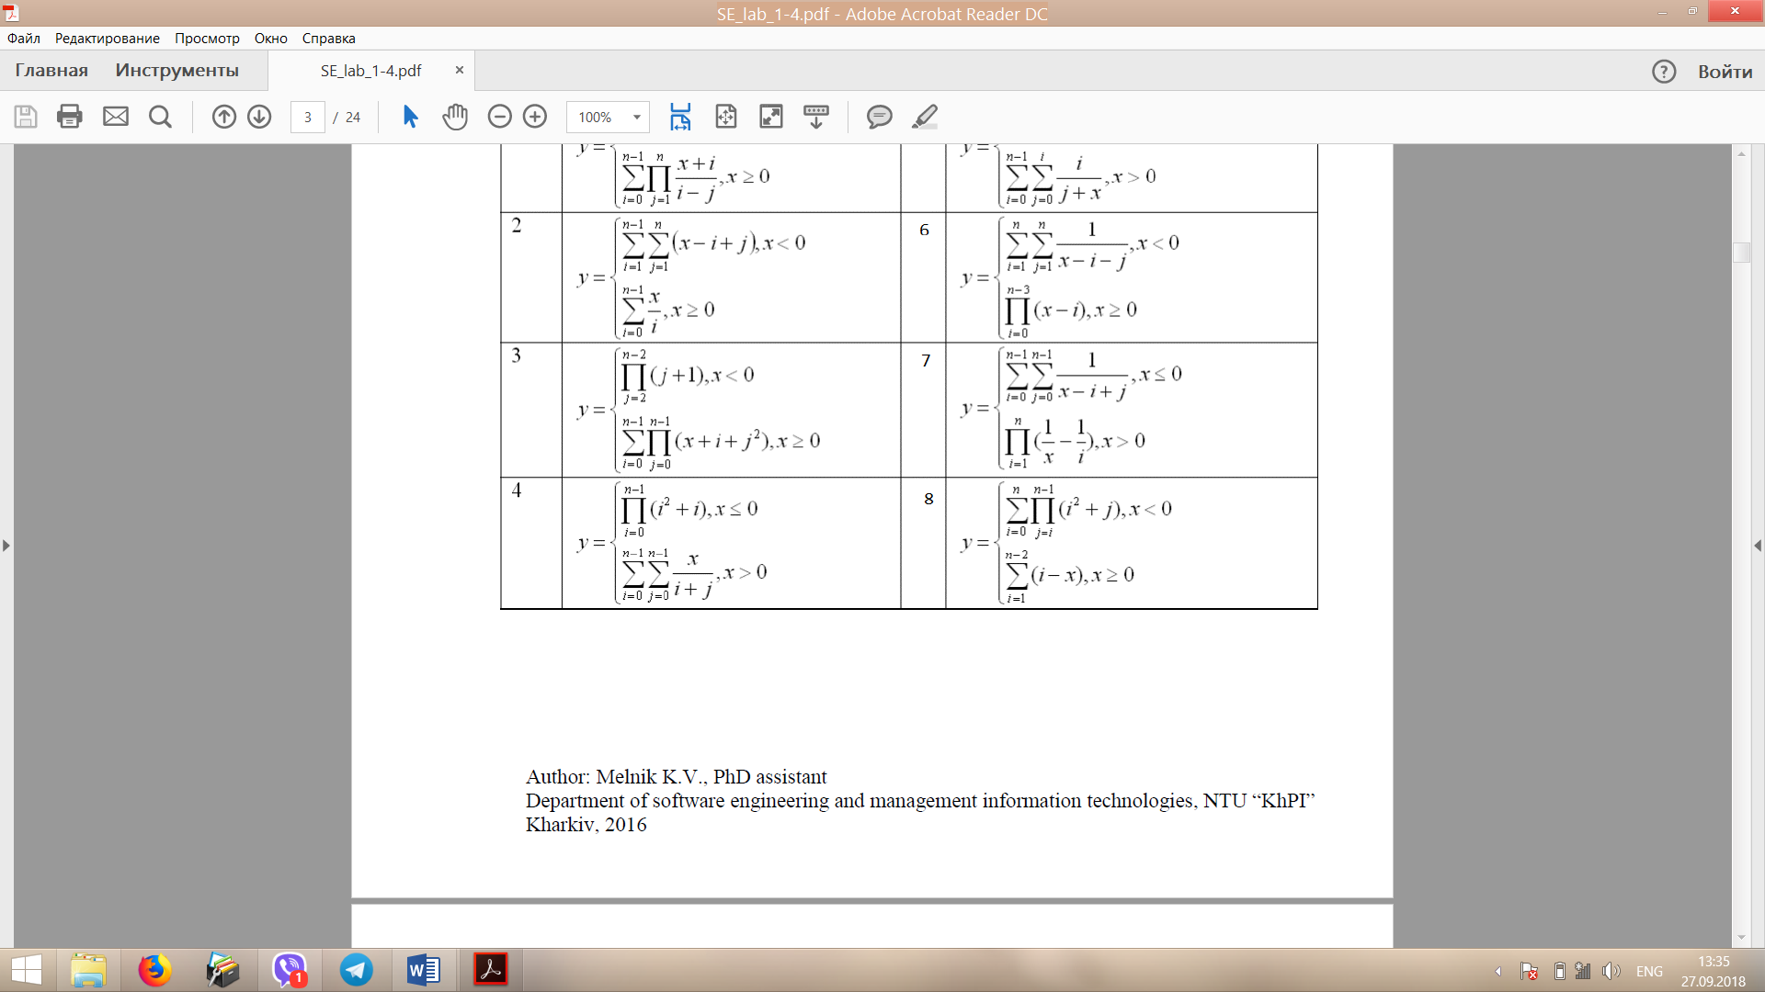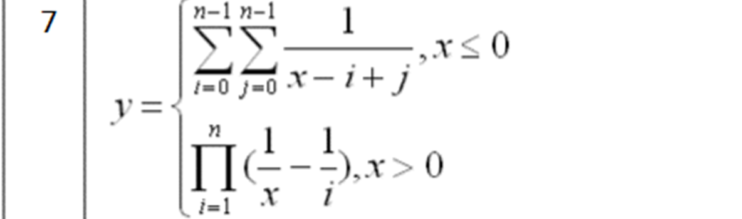

Task 1 : The code

#include<iostream>

#include<math.h>

using namespace std;

//PROGRAMME FOR SOLVING QUADRATIC EQUATION

void main(){

double a, b, c, D,x1,x2;cout << "Programme for solving quadratic equation" << endl << "ax^2 + bx + c = 0" << endl;

m1:cout << "Input a" << endl;

cin >> a;

if (a == 0) {

cout << "Invalid data"<<endl;

goto m1;

}

cout << "Input b" << endl;

cin >> b;

cout << "Input c" << endl;

cin >> c;

D = pow(b, 2) - 4\*a\*c;

if (D >= 0) {

x1 = (-b + sqrt(D)) / 2 \* a;

x2 = (-b + sqrt(D)) / 2 \* a;

cout << "The answer : " << endl << "x1 = " << x1 << " " << "x2 = " << x2 << endl;

}

else{

cout << "No real roots"<<endl;

}

system("pause");

}

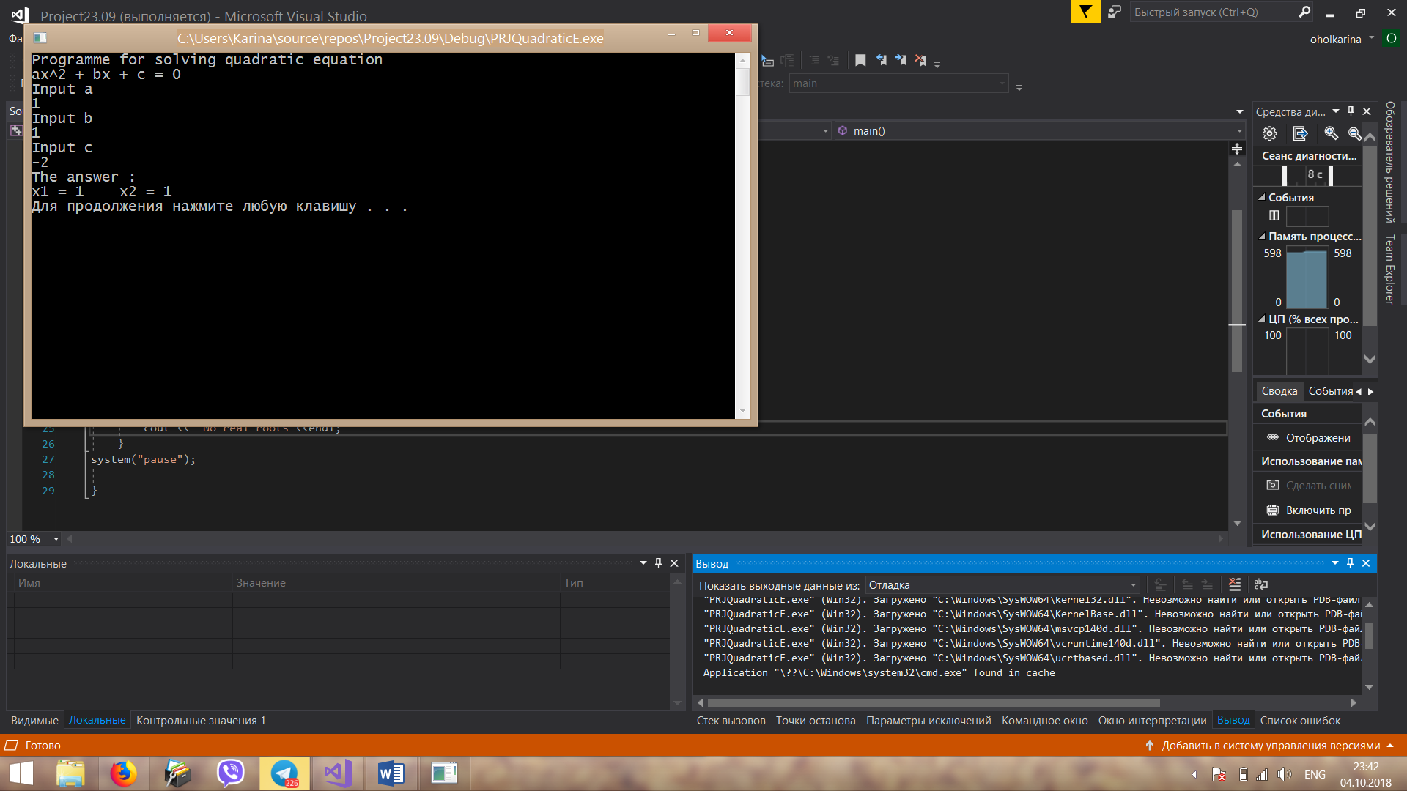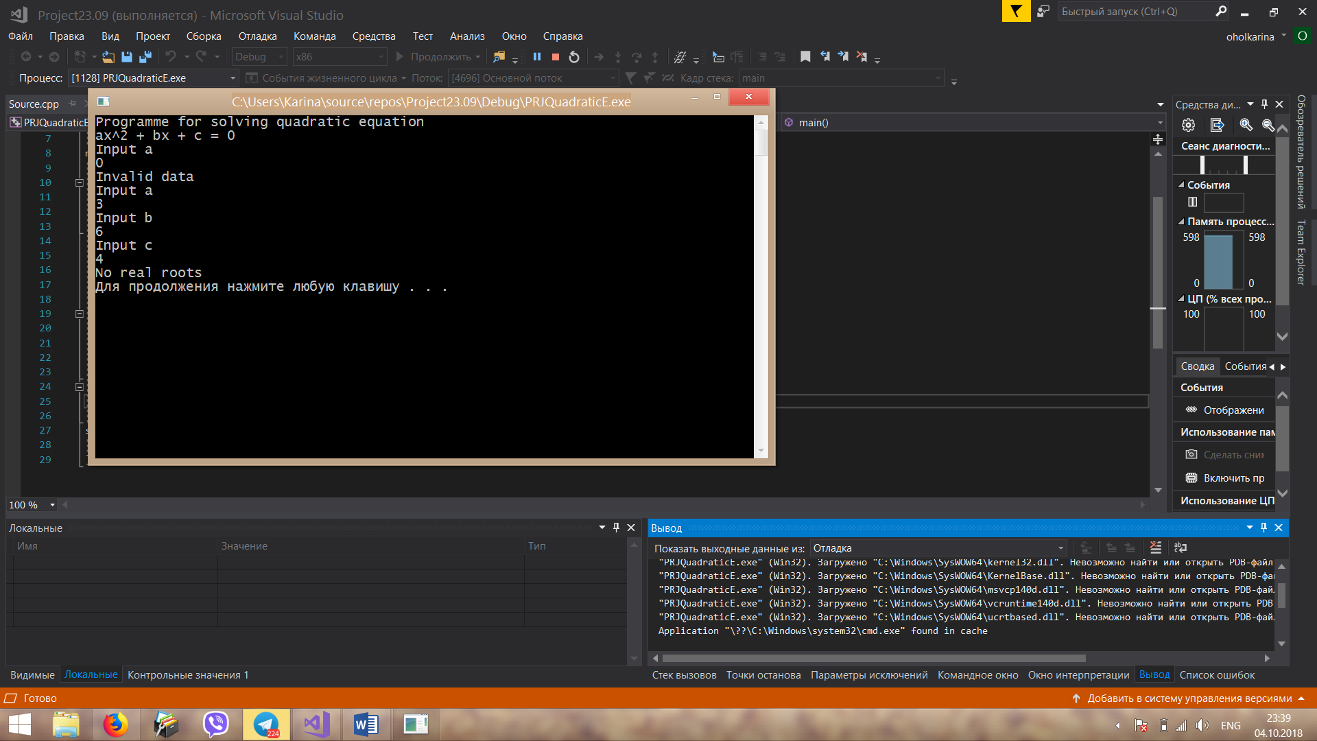Task 1: Execution result

Task 2 : The code

#include<iostream>

using namespace std;

//PROGRAMME FOR CALCULATIN y = 1/(x + 2) + 2/(x + 4) + ... + (k - 1)/(x + 2(k - 1)) + (k + 1)/(x + 2(k + 1)) + ... + n/(x + 2n)

int main()

{

int x, n;

int i;

double a,y = 0;

cout << "PROGRAMME FOR CALCULATIN y = 1/(x + 2) + 2/(x + 4) + ... + (k - 1)/(x + 2(k - 1)) + (k + 1)/(x + 2(k + 1)) + ... + n/(x + 2n)" << endl;

cout << "Input x ";

cin >> x;

cout << "Input n ";

cin >> n;

for (i = 0; i <= n; i++) {

a = 0;

if (i % 2 == 0)

{

a = i + 1;

}

else {

a = i - 1;

}

if (-2 \* a == x )

{

cout << "Error.Division by zero" << endl;

system("pause");

return 0;

}

y += a / (x + (2 \* a));

}

cout << "Result : " << y << endl;

system("pause");

return 0;

}

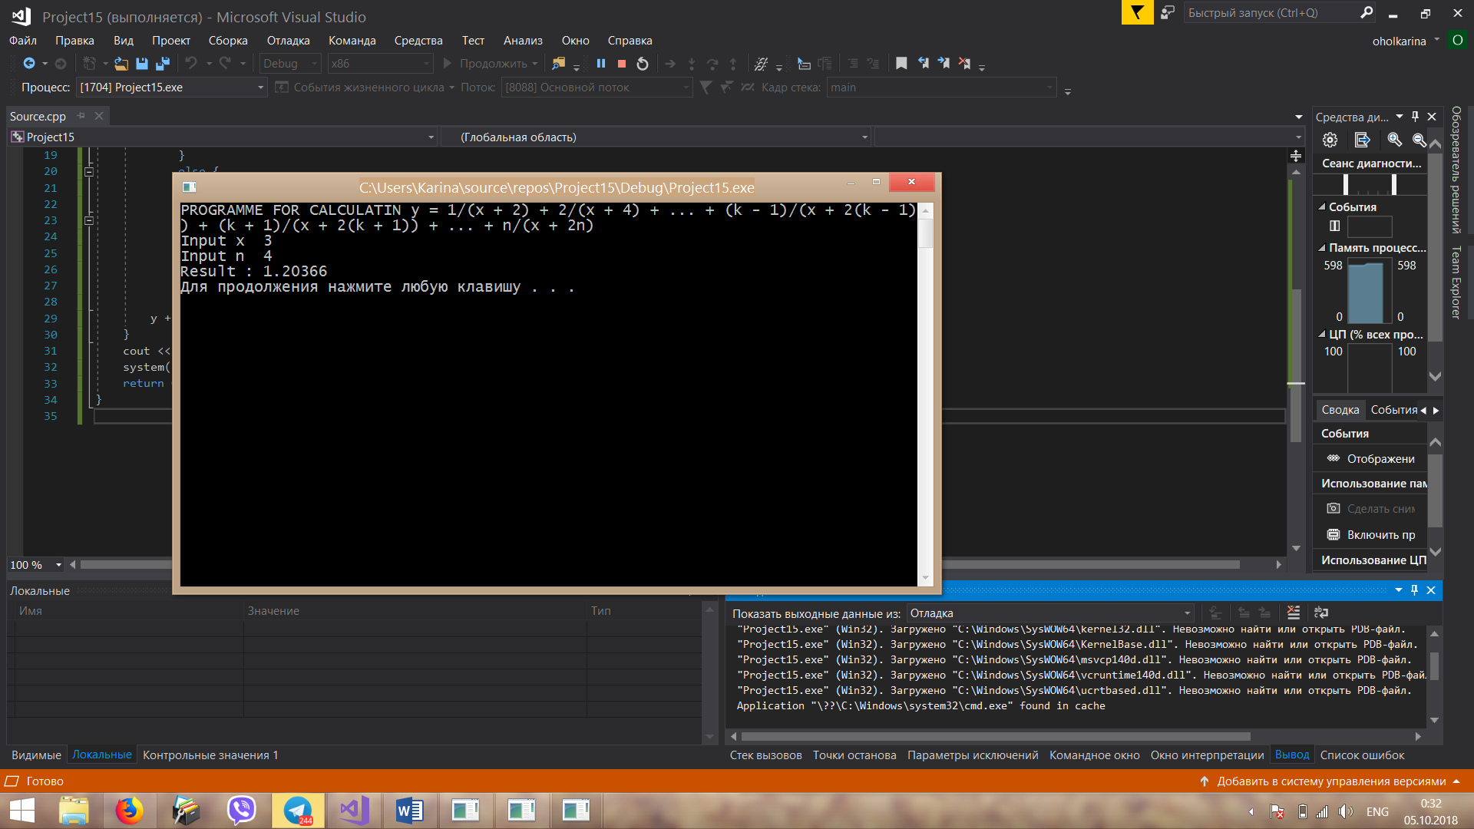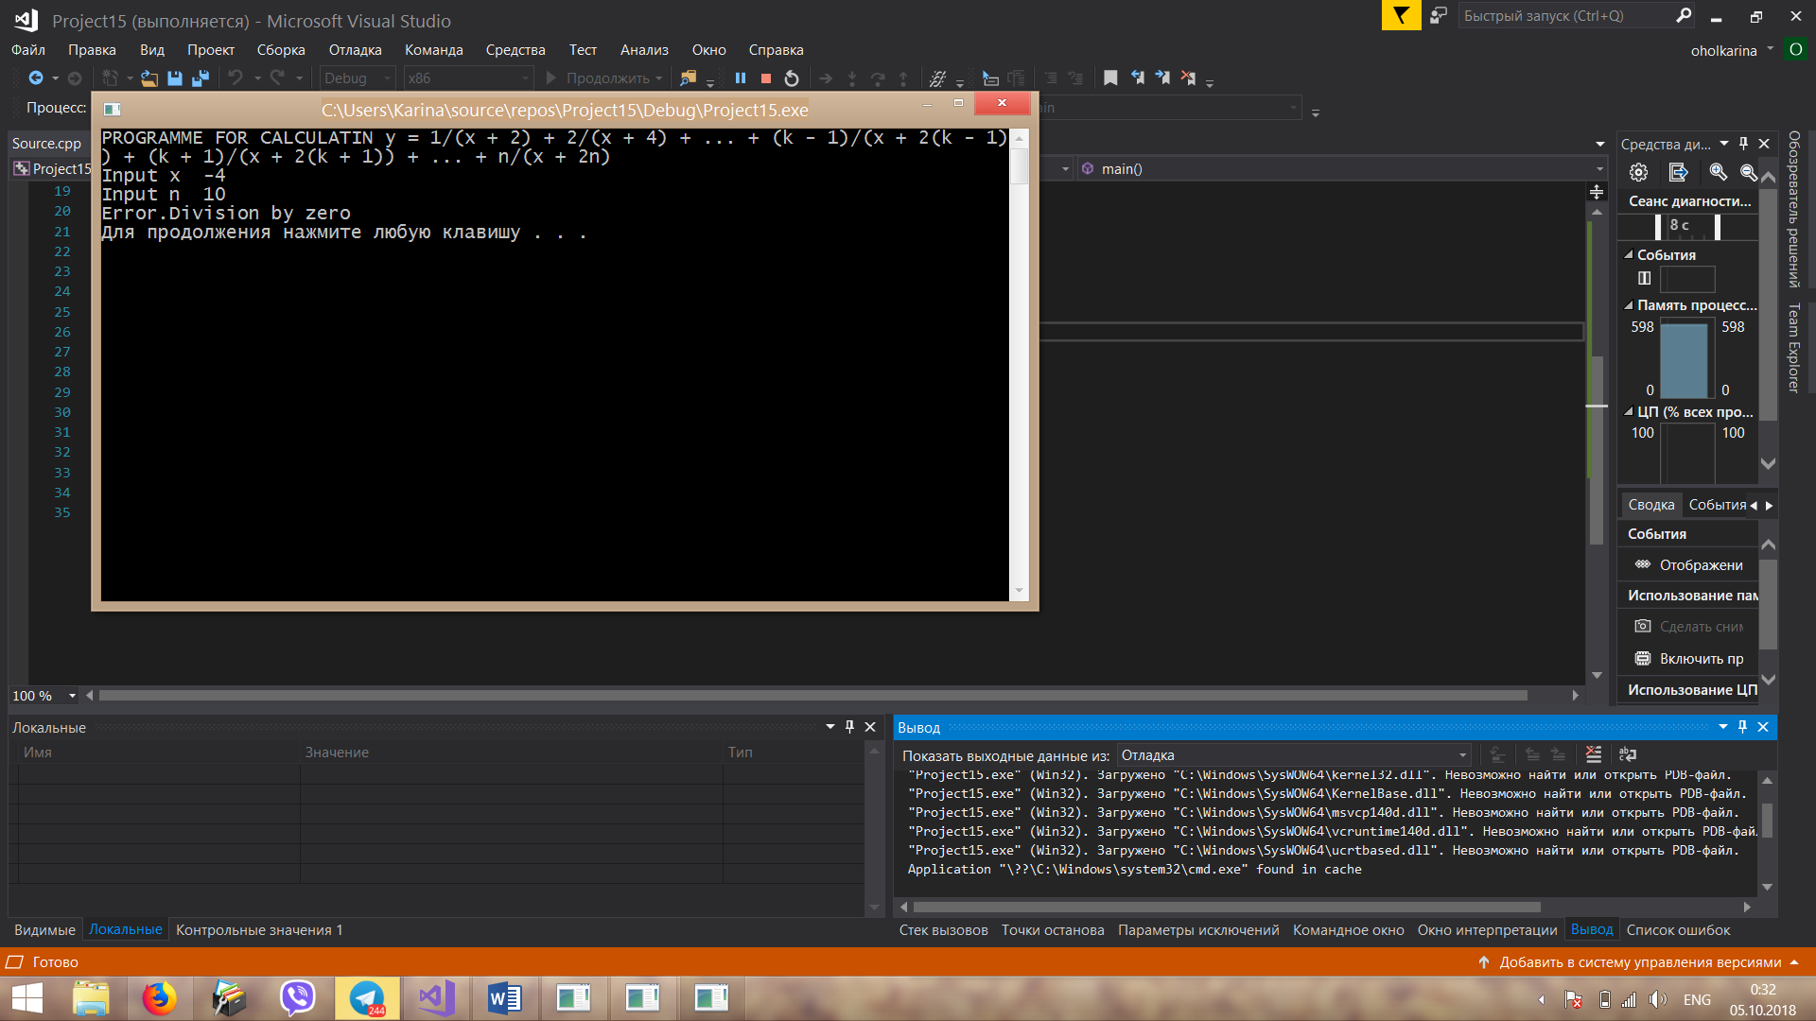Task 2: Execution result

Task 3 : The code

#include<iostream>

using namespace std;

//PROGRAMME FOR CALCULATIN y = (x+1)(x-2)(x+3)(x-4)...(x-2n)

void main() {

int x, n,y=1;

int i;

cout << "Input x";

cin >> x ;

cout << "Input n";

cin >> n;

for (i = 1; i <= 2 \* n; i++) {

if (i != 2\*n) {

if (i % 2 == 0) {

y \*= x - i;

}

else {

y \*= x + i;

}

}

}

cout << "Result : " << y << endl;

system("pause");

}

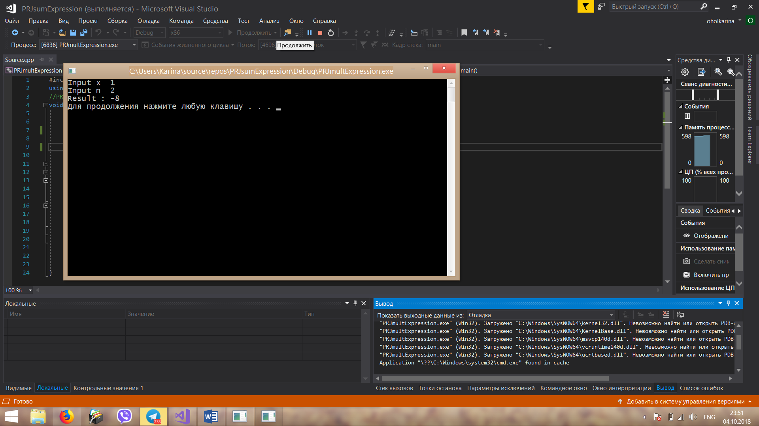Task 3: Execution result

Task 4 : The code

#include<iostream>

#include<cmath>

using namespace std;

void main()

{

double eps,y = 0;

cout << "Input eps ";

cin >> eps;

int i = 1;

while(1 / pow(2, i)> eps)

{

y += 1 / pow(2, i);

i++;

}

cout << "y = " << y << endl;

system("pause");

}

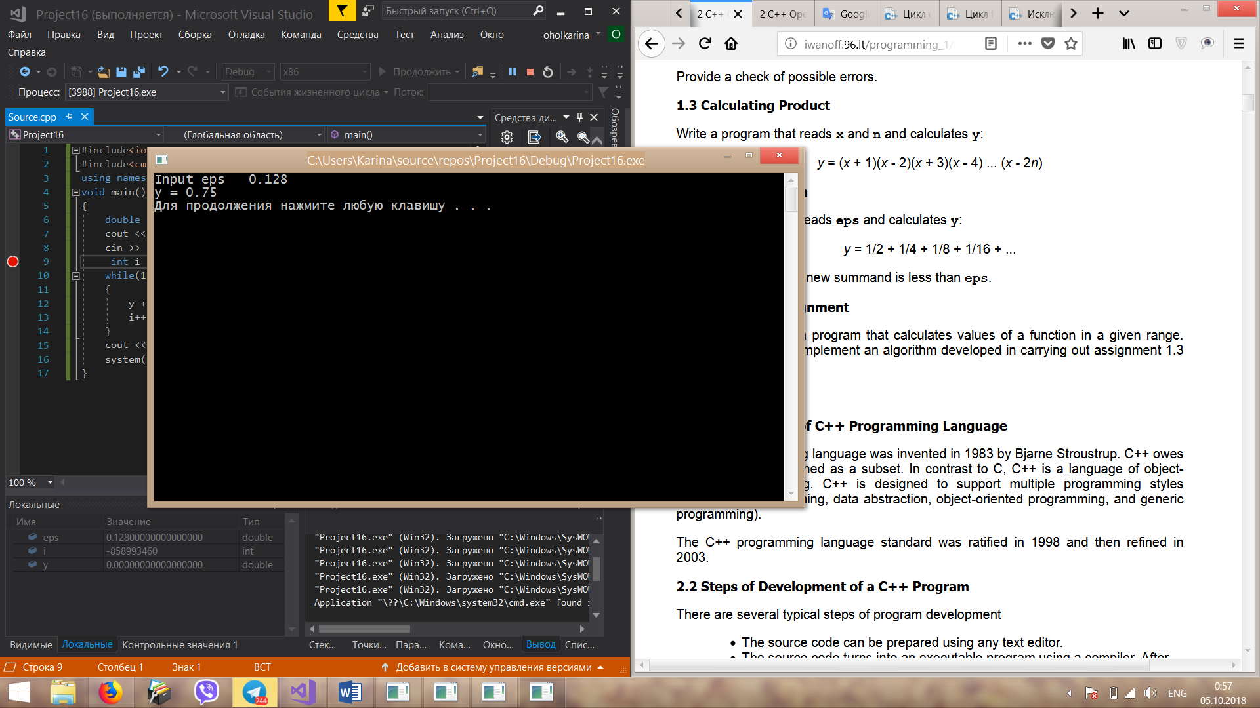Task 4: Execution result

Task 5 : The code

#include<iostream>

using namespace std;

//PROGRAMME FOR FIND Y (7 VARIANT)

void main() {

double x,y;

int i, j, n,k;

cout << "Input x ";

while (!(cin >> x) || (cin.peek() != '\n'))

{

cin.clear();

while (cin.get() != '\n');

cout << "Error! You entered non numeric data" << endl<<"Input x ";

}

cout << "Input n" << endl;

while (!(cin >> n) || (cin.peek() != '\n'))

{

cin.clear();

while (cin.get() != '\n');

cout << "Error! You entered non numeric data" << endl << "Input n ";

}

k = n - 1;

if (x > 0)

{

y = 1;

for (i = 1; i <= n; i++)

{

y \*= (1 / x) - (1 / i);

}

}

else

{

y = 0;

for (i = 1; i <= k; i++)

{

for (j = 1; j <=k; j++)

{

try

{

if (x - i == -j|| (x == 0 && i == j))

{

throw 123;

}

}

catch (int t)

{

cout << "Error "<<i<<" : Division by zero" << endl;

}

y += 1 / (x - i + j);

}

}

}

cout <<"The answer : y = "<< y<<endl;

system("pause");

}

Task 5: Execution result

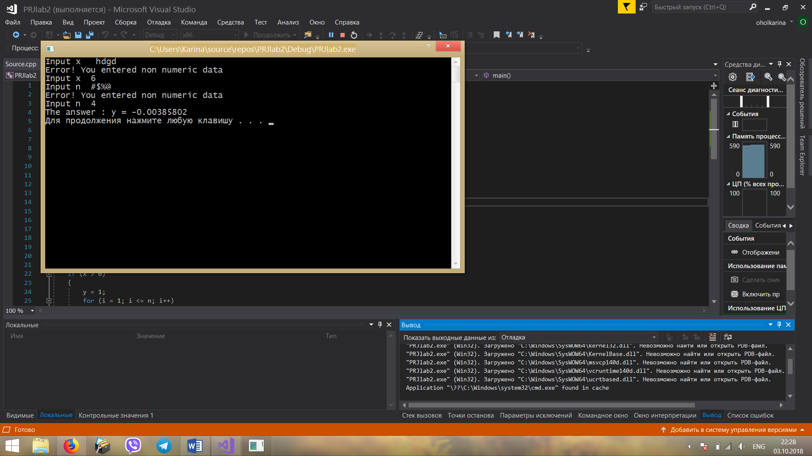

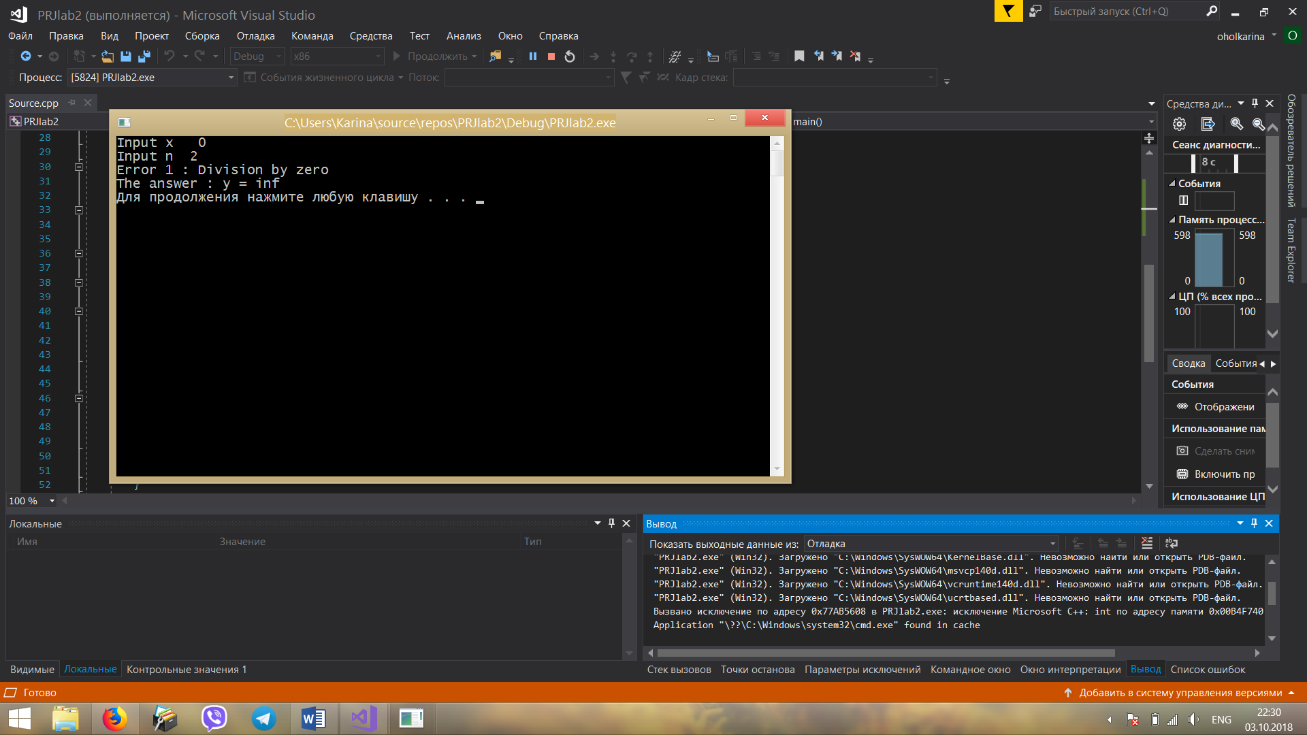

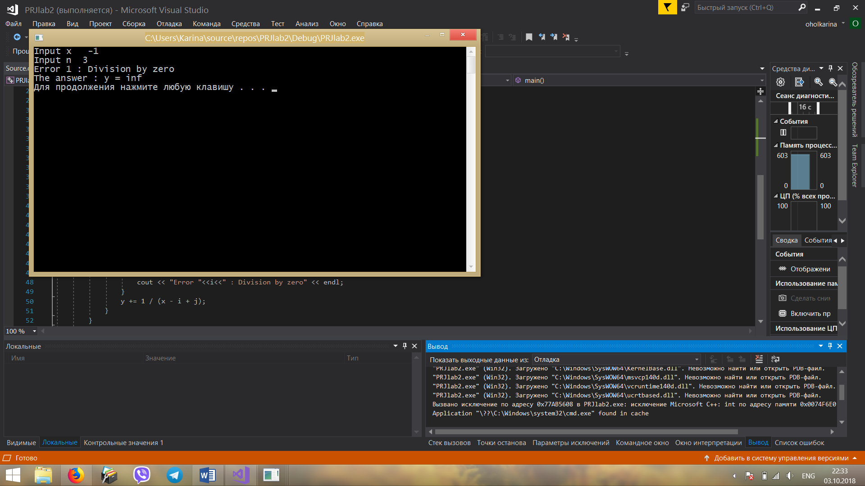

Conclusion: I received practical skills of work with basic principles of C++.I was informed about recommendations on use operators and cycles. I learned how to develop the code for the task using basic C++ operators.